**SVKM’s NMIMS**

**School of Technology Management & Engineering, Chandigarh**

A.Y. 2023 - 24

**Course: Database Management Systems**

**Project Report**

|  |  |  |
| --- | --- | --- |
| Program | BTECH CE | |
| Semester | SEM-IV | |
| Name of the Project: | Hospital Mangement | |
|  | | |
| Details of Project Members |  |  |
| Batch | Roll No. | Name |
| B1 | A149 | Pranay Kumar |
| B1 | A176 | Archit Sharma |
| B1 | A166 | Vedashree Bhandigare |
| Date of Submission: 27/03/2024 | | |

**Contribution of each project Members:**

|  |  |  |
| --- | --- | --- |
| Roll No. | Name: | Contribution |
| A149 | Pranay Kumar | ER Diagram, Report,  Normalization, Relational Table |
| A166 | Vedashree Bhandigare | ER Diagram, Tables and queries generation , Normalization |
| A176 | Archit Sharma | ER Diagram, Tables and queries generation , Normalization |

**Github link of your project:**

**Note:**

1. Create a readme file if you have multiple files
2. All files must be properly named (Example:R004_DBMSProject)
3. Submit all relevant files of your work ( Report, all SQL files, Any other files)
4. **Plagiarism is highly discouraged (Your report will be checked for plagiarism)**

**Rubrics for the Project evaluation:**

|  |  |
| --- | --- |
| First phase of evaluation:  Innovative Ideas (5 Marks)  Design and Partial implementation (5 Marks) | 10 marks |
| Final phase of evaluation  Implementation, presentation and viva, Self-Learning and Learning Beyond classroom | 10 marks |

**Project Report**

**HOSPITAL MANAGEMENT**

**By**

**Pranay Kumar, Roll number: A149**

**Vedashree Bhandigare, Roll number: A166**

**Archit Sharma , Roll number: A176**

**Course: DBMS**

**AY: 2023-24**

**Table of Contents**

|  |  |  |
| --- | --- | --- |
| **Sr no.** | **Topic** | **Page no.** |
| **1** | Storyline | 5 |
| **2** | Components of Database Design | 5-6 |
| **3** | Entity Relationship Diagram | 7 |
| **4** | Relational Model | 8 |
| **5** | Normalization | 9 |
| **6** | SQL Queries | 10-17 |
| **7** | Learning from the Project | 17 |
| **8** | Project Demonstration | 17 |
| **9** | Self-learning beyond classroom | 17 |
| **10** | Learning from the project | 17 |
| **8** | Challenges faced | 18 |
| **9** | Conclusion | 20 |

**I. Storyline**

Maintaining efficient resource and data management is critical for delivering quality healthcare services. Our hospital management database project aims to address this need by creating a comprehensive system to streamline various processes within a healthcare facility. The project plan outlines key requirements, such as patient registration, employee tracking, room allocation, billing, and record management. By detailing these requirements, we establish the scope of the project and set clear objectives for database design and implementation. This plan serves as a guiding framework to ensure all aspects of the hospital management system are considered and addressed effectively.

**II. Components of Database Design**

The components of database design encompass entities, attributes, and relationships, forming the backbone of the hospital management system. Entities represent real-world objects such as patients, doctors, nurses, and rooms, each characterized by a set of attributes like name, gender, and contact information. These attributes provide essential details for data storage and retrieval. Additionally, relationships define how entities interact with each other, specifying the cardinality and participation constraints. For instance, the relationship between patients and rooms may be one-to-one, indicating that each patient is assigned a single room. Understanding and defining these components are crucial for designing a robust and efficient database system that accurately reflects the operations and requirements of a healthcare facility.

**Entities and Attributes:**

1. Patient
   * P_Id (Primary Key)
   * P_Name
   * Gender
   * DOB
   * Mob_No
   * Age
2. Employee
   * E_Id (Primary Key)
   * Address
   * Gender
   * DOB
   * Mob_No
   * Salary
3. Doctor
   * D_Name
   * Dept
   * Qualification
4. Nurse
   * N_Name
   * Shift
5. Receptionist
   * Re_Name
6. Rooms
   * R_Id (Primary Key)
   * R_Type
   * P_Id (Foreign Key)
   * Availability
   * D_Name
7. Records
   * Record_no
   * App_no
8. Bills
   * B_Id (Primary Key)
   * P_Id (Foreign Key)
   * Amount
9. Test_Report
   * R_Id
   * P_Id (Foreign Key)
   * Test_type
   * Result

.

**III. Entity Relationship Diagram**

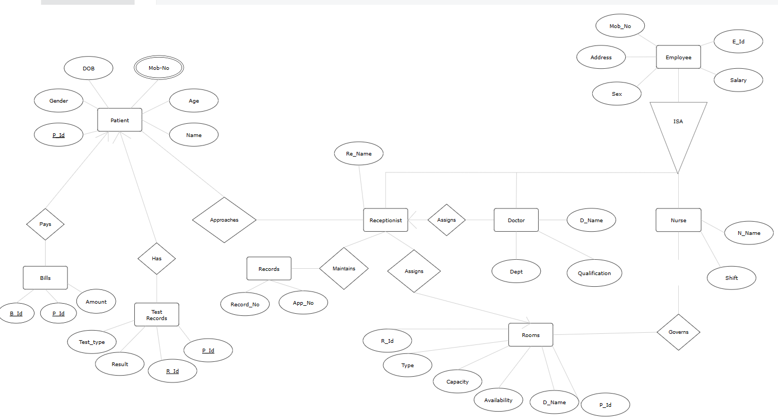

**IV. Relational Model**

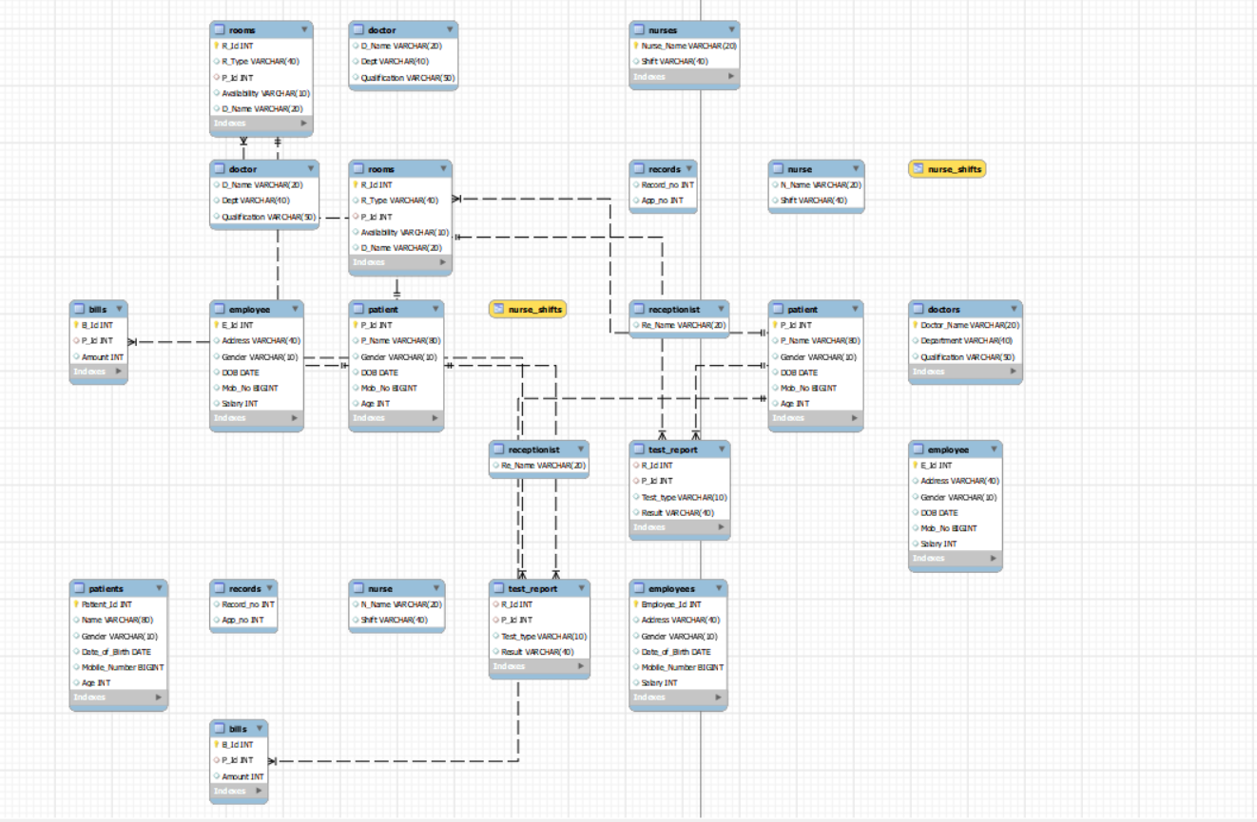

**V. Normalization**

Step 1: Identify Functional Dependencies

• Patient Table (P_Id, P_Name, Gender, DOB, Mob_No, Age)

• P_Id -> P_Name, Gender, DOB, Mob_No, Age

• There are no partial dependencies. It's in 1st Normal Form (1NF).

• Employee Table (E_Id, Address, Gender, DOB, Mob_No, Salary)

• E_Id -> Address, Gender, DOB, Mob_No, Salary

• There are no partial dependencies. It's in 1NF.

• Doctor Table (D_Name, Dept, Qualification)

• D_Name -> Dept, Qualification

• There are no partial dependencies. It's in 1NF.

• Nurse Table (N_Name, Shift)

• There are no functional dependencies. It's in 1NF.

• Receptionist Table (Re_Name)

• There are no functional dependencies. It's in 1NF.

• Rooms Table (R_Id, R_Type, P_Id, Availability, D_Name)

• R_Id -> R_Type, P_Id, Availability, D_Name

• There are no partial dependencies. It's in 1NF.

• Records Table (Record_no, App_no)

• There are no functional dependencies. It's in 1NF.

• Bills Table (B_Id, P_Id, Amount)

• There are no functional dependencies. It's in 1NF.

• Test_Report Table (R_Id, P_Id, Test_type, Result)

• There are no functional dependencies. It's in 1NF.

Step 2: Normalize to 2nd Normal Form (2NF)

Tables are already in 2NF since there are no partial dependencies in any table.

Step 3: Normalize to 3rd Normal Form (3NF)

Tables are already in 3NF since there are no transitive dependencies in any table.

Step 4: Normalize to Boyce-Codd Normal Form (BCNF)

Tables are already in BCNF since there are no non-trivial functional dependencies where a determinant is not a superkey in any table.

**VI. SQL Queries**

1.

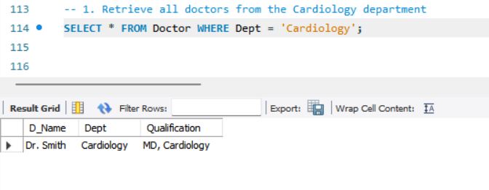

2.

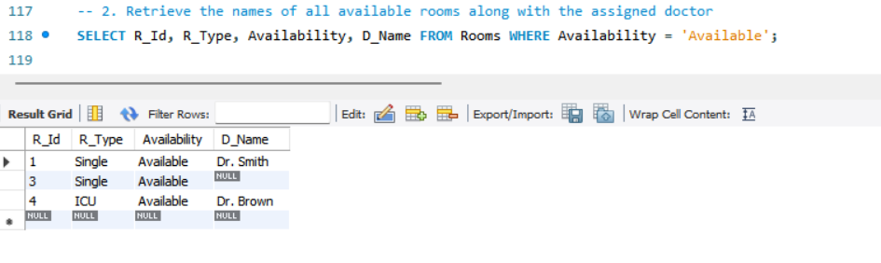

3.

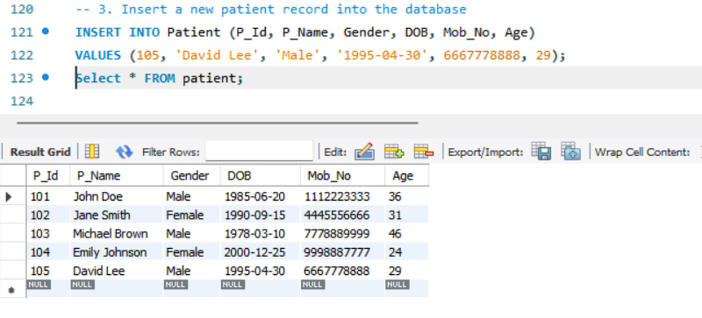

4.

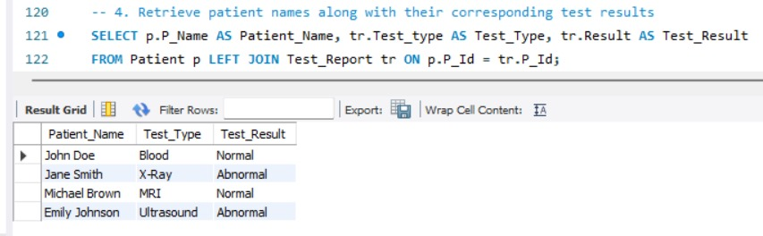

5.

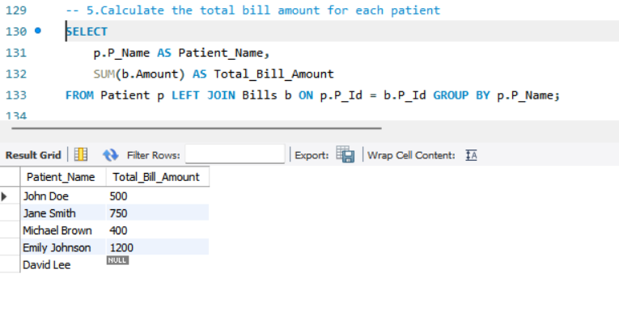

6.1.

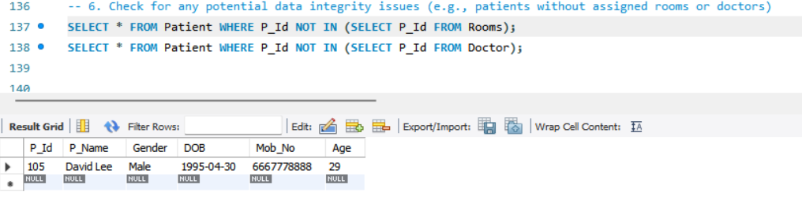

6.2.

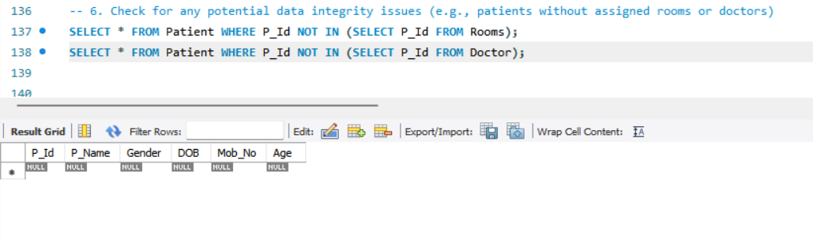

7.

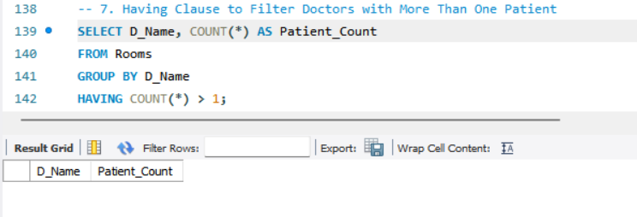

8.

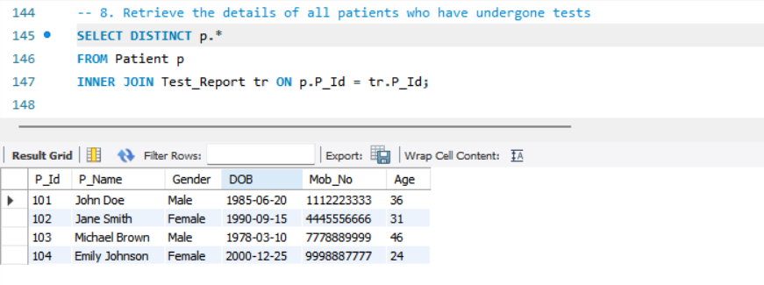

9.

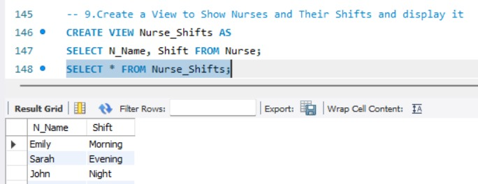

10.

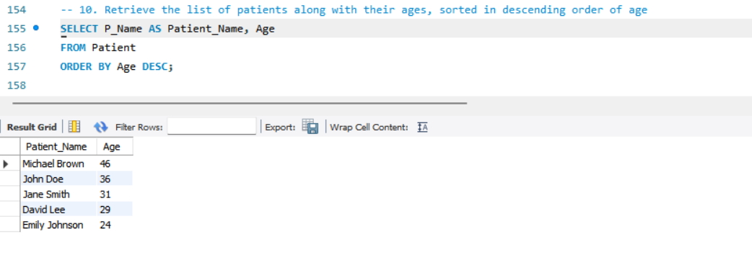

11.

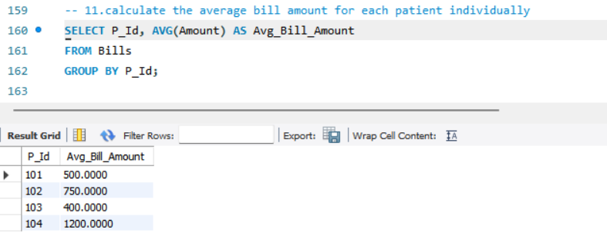

12.

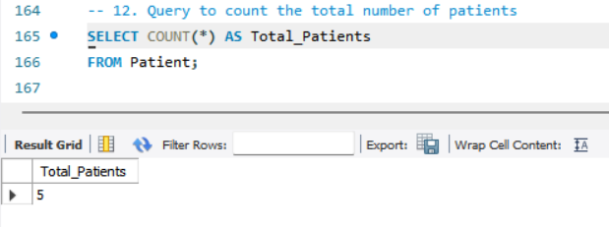

13.

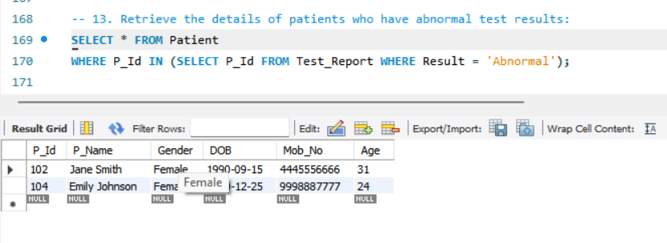

14.

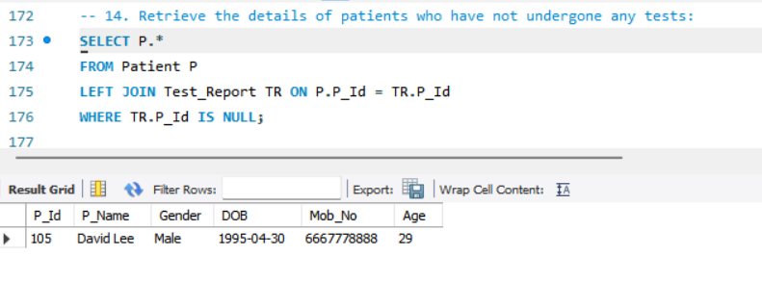

15.

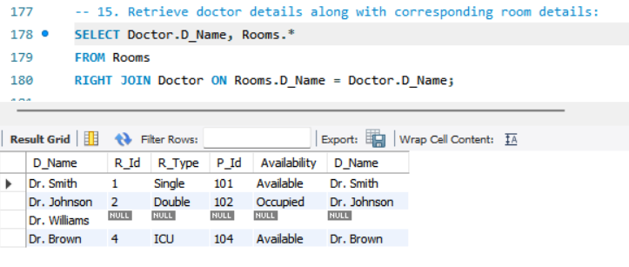

16.

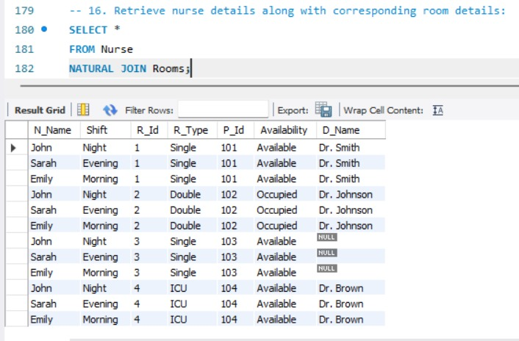

**17.**

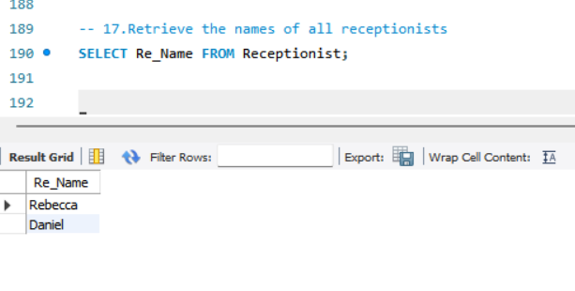

**18.**

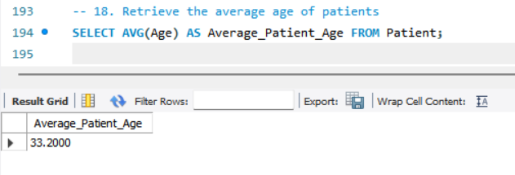

**19.**

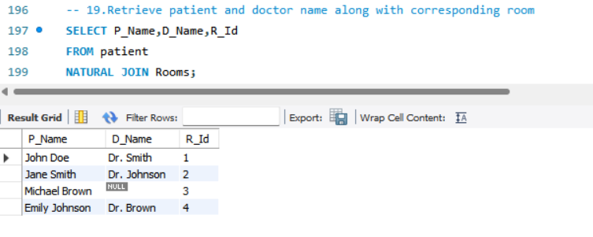

**20.**

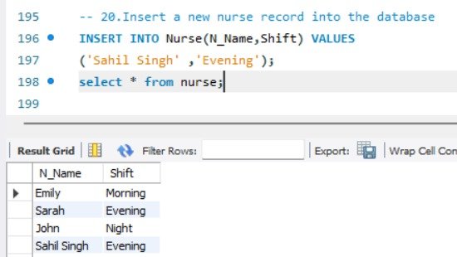

**VI. Project demonstration**

The project demonstration involves showcasing the functionality and usability of the hospital management database system. This may include displaying the database tables, executing sample queries, and if applicable, presenting a graphical user interface (GUI) for interacting with the database. Screenshots and descriptions of various features like patient registration, room allocation, billing, and reporting can be included. The demonstration provides stakeholders with a clear understanding of how the database system operates and its potential benefits for healthcare facilities.

**VII. Self -Learning beyond classroom**

:

Beyond the classroom, self-learning involved exploring advanced SQL queries, database normalization techniques, and potentially learning to develop a GUI interface for the database application. Additionally, delving into integrating databases with programming languages like Python for more dynamic applications was crucial. Self-learning broadened understanding beyond the basics taught in class, enhancing problem-solving skills and providing practical experience in software development**.**

**VIII. Learning from the Project**

The project provided valuable insights into database design principles, healthcare system operations, project management, and teamwork. It allowed for the application of theoretical knowledge to real-world scenarios, solidifying understanding and fostering critical thinking. Moreover, it facilitated gaining practical experience in software development methodologies, such as requirements analysis, design, implementation, testing, and deployment.

**IX. Challenges Faced**

Throughout the project, several challenges were encountered, including complex database relationships, ensuring data consistency, and potential difficulties in GUI development. Additionally, managing project timelines, coordinating team efforts, and addressing unforeseen technical issues posed significant challenges. However, overcoming these hurdles strengthened problem-solving skills, improved adaptability, and enhanced resilience in the face of adversity.

**X. Conclusion**

In conclusion, the hospital management database project served as an invaluable learning experience, providing hands-on exposure to database management, software development, and teamwork. Key takeaways from the project include an enhanced understanding of database design principles, insights into healthcare system operations, improved project management skills, and valuable experience in software development methodologies. Moving forward, these learnings will serve as a solid foundation for tackling more complex projects and contributing effectively to the field of healthcare management and technology.